

Pharmacy Board of Australia

Registrant Data

Reporting period: 1 July 2016 – 30 September 2016

Table of contents
Introduction 3
Principal Place of Practice 4
1. Registration Type 4
Age Group 5
4. Registration Type and Sub type 5
Gender 6
5. Registration Type 6
6. Percentage 6

Introduction
The role of the Pharmacy Board of Australia (the Board) includes:
- registering pharmacists and students
- developing standards, codes and guidelines for the pharmacy profession
- handling notifications, complaints, investigations and disciplinary hearings
- overseeing the assessment of overseas trained pharmacists who wish to practise in Australia, and
- approving accreditation standards and accredited courses of study.

The Board’s functions are supported by the Australian Health Practitioner Regulation Agency (AHPRA). For information about legislation governing our operations see About AHPRA at http://www.ahpra.gov.au/About-AHPRA/What-We-Do/Legislation.aspx.
The Board has analysed its registration data and produced a number of statistical breakdowns about registrants to share with the profession and community. The Board shares these breakdowns regularly.
For more information on pharmacy registration, please see the Board’s website http://www.pharmacyboard.gov.au/Registration.aspx

Principal Place of Practice
- Registration Type
  - Registration type and sub type by principal place of practice
Registration Type | Sub Type | ACT | NSW | NT | QLD | SA | TAS | VIC | WA | No PPP | Total
General |  | 465 | 8,335 | 202 | 5,407 | 1,972 | 658 | 6,709 | 2,970 | 355 | 27,073
Provisional |  | 42 | 584 | 14 | 365 | 116 | 41 | 386 | 145 | 4 | 1,697
Limited | Postgraduate training or supervised practice |  | 2 |  | 1 |  |  | 3 | 2 | 1 | 9
Non-practising |  | 15 | 260 | 2 | 117 | 47 | 9 | 291 | 54 | 245 | 1,040
Total |  | 522 | 9,181 | 218 | 5,890 | 2,135 | 708 | 7,389 | 3,171 | 605 | 29,819

  - Registration type by principal place of practice percentages

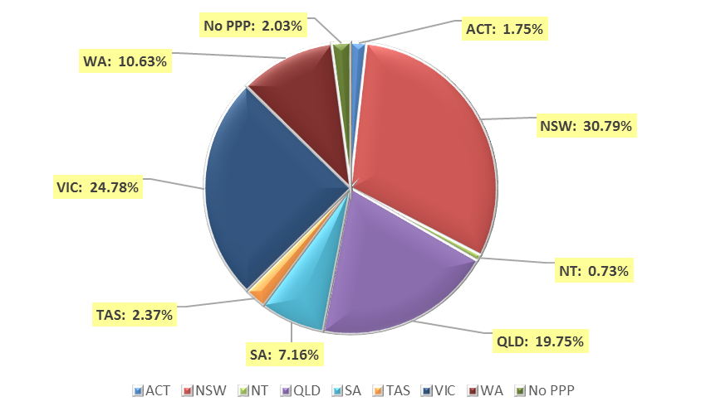

Age Group
- Registration Type and Sub type
  - Registration by age group
Age Group | General | Provisional | Limited | Non-practising | Total
Age Group | General | Provisional | Post graduate training or supervised practice | Non-practising | Total
U - 25 | 1,163 | 945 |  | 1 | 2,109
25 - 29 | 5,716 | 460 | 2 | 56 | 6,234
30 - 34 | 5,567 | 159 | 5 | 166 | 5,897
35 - 39 | 3,846 | 74 |  | 143 | 4,063
40 - 44 | 2,531 | 38 | 2 | 104 | 2,675
45 - 49 | 2,129 | 13 |  | 107 | 2,249
50 - 54 | 1,684 | 8 |  | 108 | 1,800
55 - 59 | 1,724 |  |  | 83 | 1,807
60 - 64 | 1,198 |  |  | 70 | 1,268
65 - 69 | 775 |  |  | 54 | 829
70 - 74 | 402 |  |  | 48 | 450
75 - 79 | 262 |  |  | 46 | 308
80+ | 76 |  |  | 54 | 130
Total | 27,073 | 1,697 | 9 | 1,040 | 29,819

  - Registration by age group

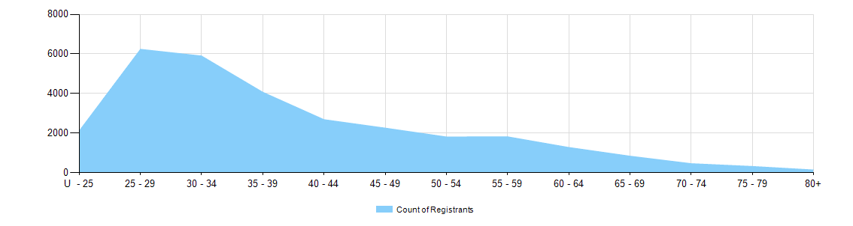

Gender
- Registration Type
  - Gender by state and territory by registration type
Gender | Registration Type | Sub Type | ACT | NSW | NT | QLD | SA | TAS | VIC | WA | No PPP | Total
Female | General |  | 300 | 5,049 | 129 | 3,342 | 1,192 | 376 | 4,056 | 1,858 | 229 | 16,531
Female | Provisional |  | 26 | 382 | 12 | 231 | 81 | 29 | 273 | 101 | 2 | 1,137
Female | Limited | Postgrad training or supervised practice |  | 2 |  | 1 |  |  | 3 | 2 |  | 8
Female | Non-practising |  | 15 | 166 | 1 | 64 | 26 | 5 | 162 | 31 | 165 | 635
Total Female |  |  | 341 | 5,599 | 142 | 3,638 | 1,299 | 410 | 4,494 | 1,992 | 396 | 18,311
Male | General |  | 165 | 3,286 | 73 | 2,065 | 780 | 282 | 2,653 | 1,112 | 126 | 10,542
Male | Provisional |  | 16 | 202 | 2 | 134 | 35 | 12 | 113 | 44 | 2 | 560
Male | Limited | Postgrad training or supervised practice |  |  |  |  |  |  |  |  | 1 | 1
Male | Non-practising |  |  | 94 | 1 | 53 | 21 | 4 | 129 | 23 | 80 | 405
Total Male |  |  | 181 | 3,582 | 76 | 2,252 | 836 | 298 | 2,895 | 1,179 | 209 | 11,508
Total |  |  | 522 | 9,181 | 218 | 5,890 | 2,135 | 708 | 7,389 | 3,171 | 605 | 29,819

- Percentage
  - Registrants by gender percentages
Gender | ACT | NSW | NT | QLD | SA | TAS | VIC | WA | No PPP | Total
Female | 65.3% | 61% | 65.1% | 61.8% | 60.8% | 57.9% | 60.8% | 62.8% | 65.5% | 61.4%
Male | 34.7% | 39% | 34.9% | 38.2% | 39.2% | 42.1% | 39.2% | 37.2% | 34.5% | 38.6%

