Pharmacy Registrant Data: March 2013

Published April 2013

Introduction
The functions of the Pharmacy Board of Australia include:
- registering pharmacists and students
- developing standards, codes and guidelines for the pharmacy profession
- handling notifications, complaints, investigations and disciplinary hearings
- assessing overseas trained practitioners who wish to practise in Australia
- approving accreditation standards and accredited courses of study.

The Board’s functions are supported by Australian Health Practitioner Regulation Agency (AHPRA). For information about legislation governing our operations see AHPRA's Legislation & Publications at http://www.ahpra.gov.au/Legislation-and-Publications.aspx

The Board has analysed its registration data and produced a number of statistical breakdowns about registrants to share with the profession and community. The Board shares these breakdowns regularly.

For more information on pharmacy registration, please see the Board’s website:
www.pharmacyboard.gov.au/Registration.aspx

Index of Tables
Pharmacists: State and territory by registration type 2
Pharmacists: Age by registration type 3
Pharmacists: Gender by state and territory by registration type 4

Pharmacists: state and territory by registration type

State | General | Limited |  | Provisional | Non-practising | Total | % By State
 |  | Postgraduate training or supervised practice | Teaching or research
ACT | 396 |  |  | 30 | 11 | 437 | 1.61%
NSW | 7,545 | 3 |  | 618 | 233 | 8,399 | 30.85%
NT | 167 |  |  | 23 | 6 | 196 | 0.72%
QLD | 4,777 | 2 | 1 | 471 | 88 | 5,339 | 19.61%
SA | 1,797 | 2 |  | 122 | 43 | 1,964 | 7.21%
TAS | 598 |  |  | 49 | 5 | 652 | 2.39%
VIC | 6,041 | 3 |  | 376 | 281 | 6,701 | 24.61%
WA | 2,675 | 5 |  | 214 | 62 | 2,956 | 10.86%
Not Stated | 393 |  |  | 2 | 187 | 582 | 2.14%
Total | 24,389 | 15 | 1 | 1,905 | 916 | 27,226

% By state
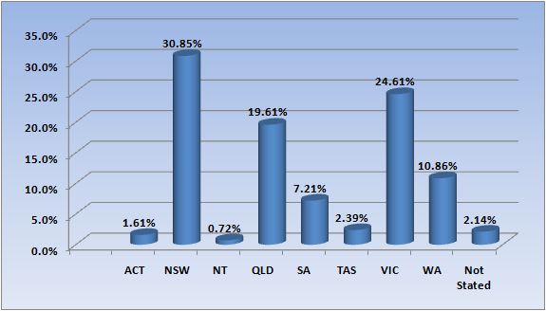

Pharmacists: Age by registration type

Age Group | General | Limited |  | Provisional | Non-practising | Total | % By Age Group
 |  | Postgraduate training or supervised practice | Teaching or research
21 - 25 | 1,804 | 1 |  | 1,244 | 3 | 3,052 | 11.21%
26 - 30 | 5,593 | 7 |  | 406 | 71 | 6,077 | 22.32%
31 - 35 | 4,285 |  |  | 140 | 115 | 4,540 | 16.68%
36 - 40 | 2,751 | 2 | 1 | 64 | 94 | 2,912 | 10.7%
41 - 45 | 2,254 | 3 |  | 28 | 113 | 2,398 | 8.81%
46 - 50 | 1,776 | 1 |  | 19 | 101 | 1,897 | 6.97%
51 - 55 | 1,845 | 1 |  | 3 | 81 | 1,930 | 7.09%
56 - 60 | 1,527 |  |  | 1 | 77 | 1,605 | 5.9%
61 - 65 | 1,093 |  |  |  | 69 | 1,162 | 4.27%
66 - 70 | 732 |  |  |  | 52 | 784 | 2.88%
71 - 75 | 478 |  |  |  | 65 | 543 | 1.99%
76 - 80 | 180 |  |  |  | 49 | 229 | 0.84%
81 - 85 | 46 |  |  |  | 17 | 63 | 0.23%
86 + | 18 |  |  |  | 9 | 27 | 0.1%
Not Stated | 7 |  |  |  |  | 7 | 0.03%
Total | 24,389 | 15 | 1 | 1,905 | 916 | 27,226

% By age group
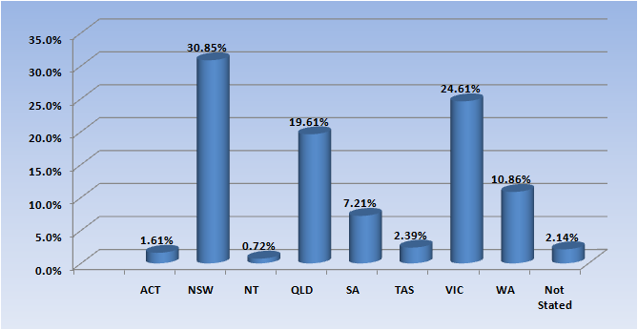

Pharmacists: Gender by state and territory by registration type
Sex | State | General | Limited |  | Provisional | Non-practising | Total Count | % By Sex By State
 |  |  | Postgraduate training or supervised practice | Teaching or research
Female | ACT | 256 |  |  | 19 | 9 | 284 | 1.04%
Female | NSW | 4,411 | 2 |  | 365 | 148 | 4,926 | 18.09%
Female | NT | 104 |  |  | 15 | 3 | 122 | 0.45%
Female | QLD | 2,833 |  | 1 | 301 | 58 | 3,193 | 11.73%
Female | SA | 1,057 | 1 |  | 79 | 21 | 1,158 | 4.25%
Female | TAS | 338 |  |  | 27 | 3 | 368 | 1.35%
Female | VIC | 3,202 | 3 |  | 242 | 158 | 3,605 | 13.24%
Female | WA | 1,630 | 5 |  | 142 | 38 | 1,815 | 6.67%
Female | Not Stated | 228 |  |  |  | 118 | 346 | 1.27%
Female | Sub total | 14,059 | 11 | 1 | 1,190 | 556 | 15,817 | 58.1%
Male | ACT | 138 |  |  | 11 | 2 | 151 | 0.55%
Male | NSW | 3,093 | 1 |  | 253 | 83 | 3,430 | 12.6%
Male | NT | 62 |  |  | 8 | 3 | 73 | 0.27%
Male | QLD | 1,937 | 2 |  | 170 | 29 | 2,138 | 7.85%
Male | SA | 737 | 1 |  | 43 | 22 | 803 | 2.95%
Male | TAS | 258 |  |  | 22 | 1 | 281 | 1.03%
Male | VIC | 2,257 |  |  | 134 | 115 | 2,506 | 9.2%
Male | WA | 1,044 |  |  | 72 | 24 | 1,140 | 4.19%
Male | Not Stated | 158 |  |  | 2 | 58 | 218 | 0.8%
Male | Sub total | 9,684 | 4 |  | 715 | 337 | 10,740 | 39.45%
Not Stated | ACT | 2 |  |  |  |  | 2 | 0.01%
Not Stated | NSW | 41 |  |  |  | 2 | 43 | 0.16%
Not Stated | NT | 1 |  |  |  |  | 1 | 0.0%
Not Stated | QLD | 7 |  |  |  | 1 | 8 | 0.03%
Not Stated | SA | 3 |  |  |  |  | 3 | 0.01%
Not Stated | TAS | 2 |  |  |  | 1 | 3 | 0.01%
Not Stated | VIC | 582 |  |  |  | 8 | 590 | 2.17%
Not Stated | WA | 1 |  |  |  |  | 1 | 0.0%
Not Stated | Not Stated | 7 |  |  |  | 11 | 18 | 0.07%
Not Stated | Sub total | 646 |  |  |  | 23 | 669 | 2.46%
Total |  | 24,389 | 15 | 1 | 1,905 | 916 | 27,226

