

Pharmacy Board of Australia

Registrant data

Reporting period: 1 October 2017 – 31 December 2017

Table of contents
Introduction 3
Principal place of practice 4
1. Registration type 4
Age group 5
4. Registration type and subtype 5
Gender 6
5. Registration type 6
6. Percentage 6

Introduction
The role of the Pharmacy Board of Australia (the Board) includes:
- registering pharmacists and students
- developing standards, codes and guidelines for the pharmacy profession
- handling notifications, complaints, investigations and disciplinary hearings
- overseeing the assessment of overseas trained pharmacists who wish to practise in Australia, and
- approving accreditation standards and accredited courses of study.

The Board’s functions are supported by the Australian Health Practitioner Regulation Agency (AHPRA). For information about legislation governing our operations see About AHPRA at www.ahpra.gov.au/About-AHPRA/What-We-Do/Legislation.aspx.
The Board has analysed its registration data and produced a number of statistical breakdowns about registrants to share with the profession and community. The Board shares these breakdowns regularly.
For more information on pharmacy registration, please see the Board’s website: www.pharmacyboard.gov.au/Registration.aspx

Principal place of practice
- Registration type
  - Registration type and subtype by principal place of practice
Registration type | Subtype | ACT | NSW | NT | QLD | SA | TAS | VIC | WA | No PPP | Total
General |  | 512 | 8,568 | 201 | 5,648 | 2,023 | 687 | 7,091 | 3,057 | 341 | 28,128
Provisional |  | 42 | 596 | 31 | 290 | 94 | 50 | 330 | 143 | 7 | 1,583
Limited | Postgraduate training or supervised practice | 1 |  |  |  | 1 |  | 3 | 2 | 2 | 9
Non-practising |  | 12 | 307 | 2 | 156 | 54 | 11 | 311 | 59 | 281 | 1,193
Total |  | 567 | 9,471 | 234 | 6,094 | 2,172 | 748 | 7,735 | 3,261 | 631 | 30,913

  - Registration type by principal place of practice percentages
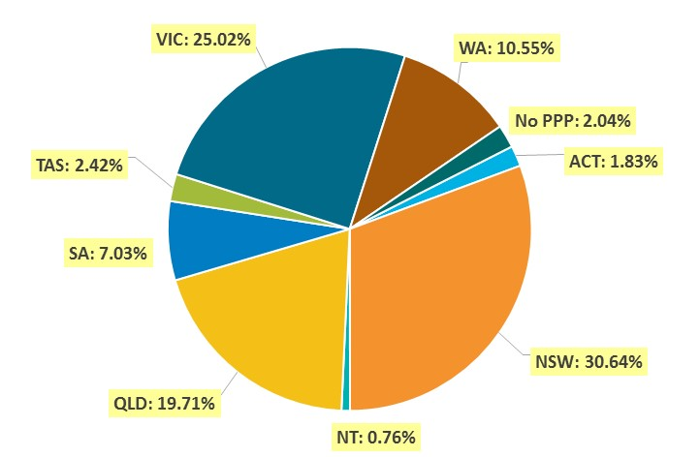

Age group
- Registration type and subtype
  - Registration by age group
Age group | General | Provisional | Limited | Non-practising | Total
Age group | General | Provisional | Post graduate training or supervised practice | Non-practising | Total
U - 25 | 1,163 | 832 |  | 2 | 1,997
25 - 29 | 5,596 | 456 | 5 | 61 | 6,118
30 - 34 | 5,950 | 161 | 1 | 195 | 6,307
35 - 39 | 4,353 | 69 | 1 | 158 | 4,581
40 - 44 | 2,699 | 36 |  | 135 | 2,870
45 - 49 | 2,220 | 18 | 1 | 125 | 2,364
50 - 54 | 1,692 | 7 |  | 111 | 1,810
55 - 59 | 1,704 | 3 | 1 | 87 | 1,795
60 - 64 | 1,285 | 1 |  | 78 | 1,364
65 - 69 | 740 |  |  | 59 | 799
70 - 74 | 417 |  |  | 58 | 475
75 - 79 | 223 |  |  | 62 | 285
80+ | 86 |  |  | 62 | 148
Total | 28,128 | 1,583 | 9 | 1,193 | 30,913

  - Registration by age group

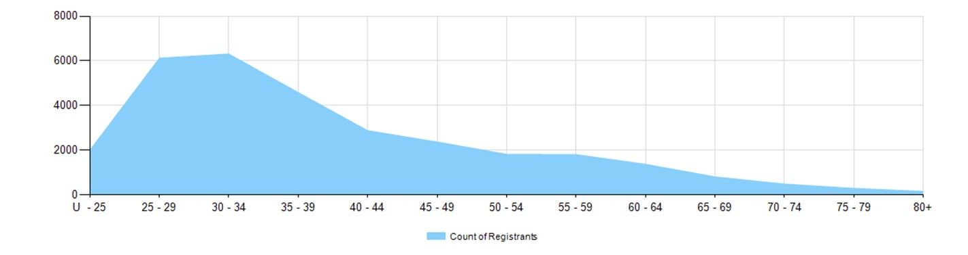

Gender
- Registration type
  - Gender by state and territory by registration type
Gender | Registration type | Subtype | ACT | NSW | NT | QLD | SA | TAS | VIC | WA | No PPP | Total
Female | General |  | 332 | 5,229 | 130 | 3,530 | 1,245 | 409 | 4,361 | 1,949 | 220 | 17,405
Female | Provisional |  | 30 | 388 | 16 | 187 | 63 | 35 | 216 | 94 | 3 | 1,032
Female | Limited | Postgrad training or supervised practice | 1 |  |  |  |  |  | 2 | 2 | 2 | 7
Female | Non-practising |  | 12 | 194 | 2 | 84 | 23 | 8 | 175 | 33 | 191 | 722
Total female |  |  | 375 | 5,811 | 148 | 3,801 | 1,331 | 452 | 4,754 | 2,078 | 416 | 19,166
Male | General |  | 180 | 3,339 | 71 | 2,118 | 778 | 278 | 2,730 | 1,108 | 121 | 10,723
Male | Provisional |  | 12 | 208 | 15 | 103 | 31 | 15 | 114 | 49 | 4 | 551
Male | Limited | Postgrad training or supervised practice |  |  |  |  | 1 |  | 1 |  |  | 2
Male | Non-practising |  |  | 113 |  | 72 | 31 | 3 | 136 | 26 | 90 | 471
Total male |  |  | 192 | 3,660 | 86 | 2,293 | 841 | 296 | 2,981 | 1,183 | 215 | 11,747
Total |  |  | 567 | 9,471 | 234 | 6,094 | 2,172 | 748 | 7,735 | 3,261 | 631 | 30,913

- Percentage
  - Registrants by gender percentages
Gender | ACT | NSW | NT | QLD | SA | TAS | VIC | WA | No PPP | Total
Female | 66.1% | 61.4% | 63.2% | 62.4% | 61.3% | 60.4% | 61.5% | 63.7% | 65.9% | 62.0%
Male | 33.9% | 38.6% | 36.8% | 37.6% | 38.7% | 39.6% | 38.5% | 36.3% | 34.1% | 38.0%

