

Pharmacy Board of Australia

Registrant data

Reporting period: 1 October 2018 – 31 December 2018

Table of contents
Introduction 3
Principal place of practice 4
1. Registration type 4
Age group 5
4. Registration type and subtype 5
Gender 6
5. Registration type 6
6. Percentage 6

Introduction
The role of the Pharmacy Board of Australia (the Board) includes:
- registering pharmacists and students
- developing standards, codes and guidelines for the pharmacy profession
- handling notifications, complaints, investigations and disciplinary hearings
- overseeing the assessment of overseas trained pharmacists who wish to practise in Australia, and
- approving accreditation standards and accredited courses of study.

The Board’s functions are supported by the Australian Health Practitioner Regulation Agency (AHPRA). For information about legislation governing our operations see About AHPRA at www.ahpra.gov.au/About-AHPRA/What-We-Do/Legislation.aspx.
The Board has analysed its registration data and produced a number of statistical breakdowns about registrants to share with the profession and community. The Board shares these breakdowns regularly.
For more information on pharmacy registration, please see the Board’s website: www.pharmacyboard.gov.au/Registration.aspx

Principal place of practice
- Registration type
  - Registration type and subtype by principal place of practice
Registration type | Subtype | ACT | NSW | NT | QLD | SA | TAS | VIC | WA | No PPP | Total
General |  | 544 | 8,739 | 222 | 5,756 | 2,030 | 699 | 7,352 | 3,093 | 334 | 28,769
Provisional |  | 51 | 486 | 29 | 335 | 119 | 64 | 391 | 142 | 13 | 1,630
Limited | Postgraduate training or supervised practice | 2 | 6 |  | 1 | 2 | 1 | 3 | 1 |  | 16
Non-practising |  | 13 | 296 | 2 | 145 | 53 | 14 | 289 | 53 | 285 | 1,150
Total |  | 610 | 9,527 | 253 | 6,237 | 2,204 | 778 | 8,035 | 3,289 | 632 | 31,565

  - Registration type by principal place of practice percentages

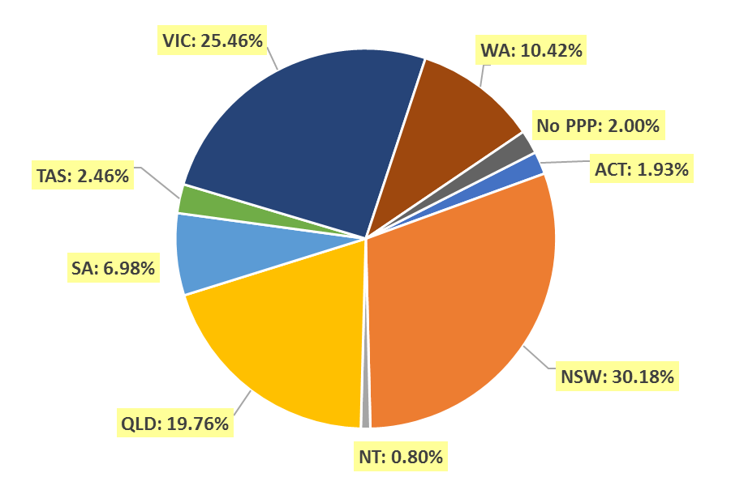

Age group
- Registration type and subtype
  - Registration by age group
Age group | General | Provisional | Limited | Non-practising | Total
Age group | General | Provisional | Post graduate training or supervised practice | Non-practising | Total
U - 25 | 983 | 823 | 1 | 1 | 1,808
25 - 29 | 5,522 | 449 | 6 | 47 | 6,024
30 - 34 | 6,093 | 202 | 5 | 172 | 6,472
35 - 39 | 4,738 | 93 | 3 | 178 | 5,012
40 - 44 | 2,934 | 41 |  | 141 | 3,116
45 - 49 | 2,298 | 11 | 1 | 125 | 2,435
50 - 54 | 1,724 | 8 |  | 107 | 1,839
55 - 59 | 1,667 | 3 |  | 92 | 1,762
60 - 64 | 1,331 |  |  | 69 | 1,400
65 - 69 | 742 |  |  | 62 | 804
70 - 74 | 430 |  |  | 54 | 484
75 - 79 | 202 |  |  | 47 | 249
80+ | 105 |  |  | 55 | 160
Total | 28,769 | 1,630 | 16 | 1,150 | 31,565

  - Registration by age group

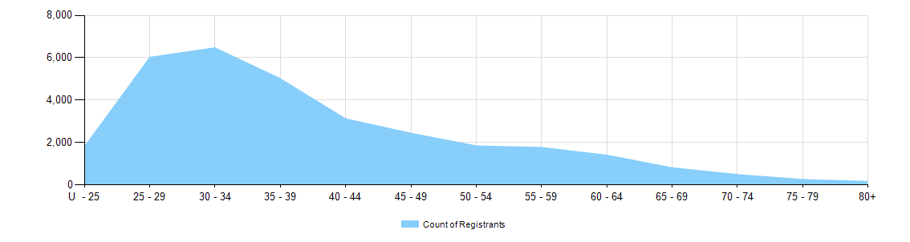

Gender
- Registration type
  - Gender by state and territory by registration type
Gender | Registration type | Subtype | ACT | NSW | NT | QLD | SA | TAS | VIC | WA | No PPP | Total
Female | General |  | 366 | 5,369 | 142 | 3,613 | 1,259 | 414 | 4,584 | 1,973 | 208 | 17,928
Female | Provisional |  | 28 | 324 | 15 | 222 | 79 | 45 | 259 | 103 | 3 | 1,078
Female | Limited | Postgrad training or supervised practice | 1 | 5 |  | 1 | 1 | 1 | 2 | 1 |  | 12
Female | Non-practising |  | 12 | 188 | 2 | 82 | 22 | 10 | 158 | 31 | 192 | 697
Total female |  |  | 407 | 5,886 | 159 | 3,918 | 1,361 | 470 | 5,003 | 2,108 | 403 | 19,715
Male | General |  | 178 | 3,370 | 80 | 2,143 | 771 | 285 | 2,768 | 1,120 | 126 | 10,841
Male | Provisional |  | 23 | 162 | 14 | 113 | 40 | 19 | 132 | 39 | 10 | 552
Male | Limited | Postgrad training or supervised practice | 1 | 1 |  |  | 1 |  | 1 |  |  | 4
Male | Non-practising |  | 1 | 108 |  | 63 | 31 | 4 | 131 | 22 | 93 | 453
Total male |  |  | 203 | 3,641 | 94 | 2,319 | 843 | 308 | 3,032 | 1,181 | 229 | 11,850
Total |  |  | 610 | 9,527 | 253 | 6,237 | 2,204 | 778 | 8,035 | 3,289 | 632 | 31,565

- Percentage
  - Registrants by gender percentages
Gender | ACT | NSW | NT | QLD | SA | TAS | VIC | WA | No PPP | Total
Female | 66.7% | 61.8% | 62.8% | 62.8% | 61.8% | 60.4% | 62.3% | 64.1% | 63.8% | 62.5%
Male | 33.3% | 38.2% | 37.2% | 37.2% | 38.2% | 39.6% | 37.7% | 35.9% | 36.2% | 37.5%

