

Pharmacy Board of Australia

Registrant data

Reporting period: 1 April 2018 – 30 June 2018

Table of contents
Introduction 3
Principal place of practice 4
1. Registration type 4
Age group 5
4. Registration type and subtype 5
Gender 6
5. Registration type 6
6. Percentage 6

Introduction
The role of the Pharmacy Board of Australia (the Board) includes:
- registering pharmacists and students
- developing standards, codes and guidelines for the pharmacy profession
- handling notifications, complaints, investigations and disciplinary hearings
- overseeing the assessment of overseas trained pharmacists who wish to practise in Australia, and
- approving accreditation standards and accredited courses of study.

The Board’s functions are supported by the Australian Health Practitioner Regulation Agency (AHPRA). For information about legislation governing our operations see About AHPRA at www.ahpra.gov.au/About-AHPRA/What-We-Do/Legislation.aspx.
The Board has analysed its registration data and produced a number of statistical breakdowns about registrants to share with the profession and community. The Board shares these breakdowns regularly.
For more information on pharmacy registration, please see the Board’s website: www.pharmacyboard.gov.au/Registration.aspx

Principal place of practice
- Registration type
  - Registration type and subtype by principal place of practice
Registration type | Subtype | ACT | NSW | NT | QLD | SA | TAS | VIC | WA | No PPP | Total
General |  | 518 | 8,601 | 219 | 5,656 | 2,017 | 679 | 7,193 | 3,062 | 302 | 28,247
Provisional |  | 46 | 541 | 32 | 369 | 139 | 48 | 379 | 150 | 6 | 1,710
Limited | Postgraduate training or supervised practice |  | 7 |  | 2 | 3 | 1 | 2 | 1 |  | 16
Non-practising |  | 13 | 294 | 2 | 140 | 52 | 13 | 286 | 53 | 282 | 1,135
Total |  | 577 | 9,443 | 253 | 6,167 | 2,211 | 741 | 7,860 | 3,266 | 590 | 31,108

  - Registration type by principal place of practice percentages
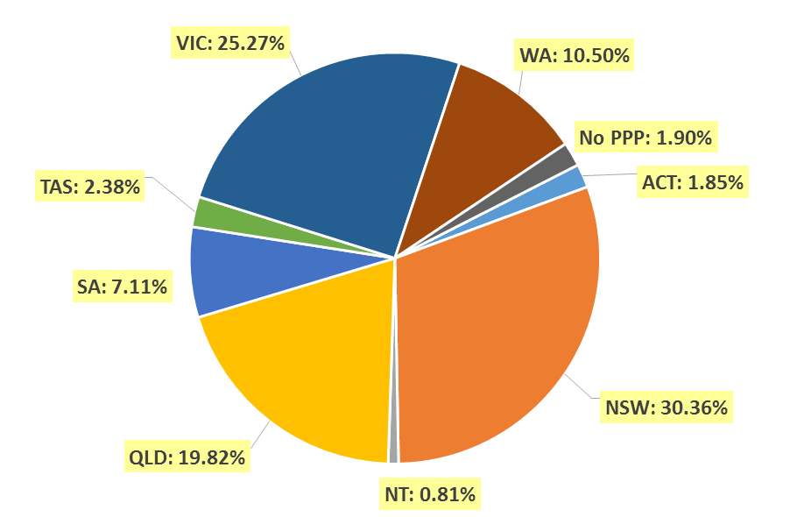

Age group
- Registration type and subtype
  - Registration by age group
Age group | General | Provisional | Limited | Non-practising | Total
Age group | General | Provisional | Post graduate training or supervised practice | Non-practising | Total
U - 25 | 1,142 | 948 | 1 |  | 2,091
25 - 29 | 5,580 | 453 | 7 | 56 | 6,096
30 - 34 | 5,968 | 178 | 2 | 180 | 6,328
35 - 39 | 4,520 | 77 | 3 | 162 | 4,762
40 - 44 | 2,775 | 32 |  | 138 | 2,945
45 - 49 | 2,246 | 10 | 2 | 131 | 2,389
50 - 54 | 1,697 | 9 |  | 104 | 1,810
55 - 59 | 1,691 | 2 | 1 | 88 | 1,782
60 - 64 | 1,246 | 1 |  | 68 | 1,315
65 - 69 | 709 |  |  | 62 | 771
70 - 74 | 379 |  |  | 49 | 428
75 - 79 | 204 |  |  | 47 | 251
80+ | 90 |  |  | 50 | 140
Total | 28,247 | 1,710 | 16 | 1,135 | 31,108

  - Registration by age group

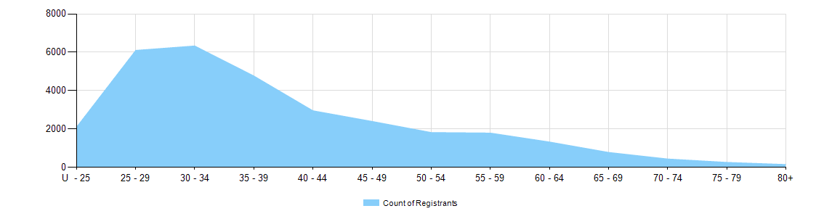

Gender
- Registration type
  - Gender by state and territory by registration type
Gender | Registration type | Subtype | ACT | NSW | NT | QLD | SA | TAS | VIC | WA | No PPP | Total
Female | General |  | 337 | 5,271 | 145 | 3,548 | 1,249 | 406 | 4,467 | 1,959 | 197 | 17,579
Female | Provisional |  | 28 | 352 | 16 | 254 | 90 | 32 | 255 | 102 | 2 | 1,131
Female | Limited | Postgrad training or supervised practice |  | 6 |  | 1 | 2 |  | 2 | 1 |  | 12
Female | Non-practising |  | 12 | 187 | 2 | 76 | 21 | 10 | 157 | 31 | 193 | 689
Total female |  |  | 377 | 5,816 | 163 | 3,879 | 1,362 | 448 | 4,881 | 2,093 | 392 | 19,411
Male | General |  | 181 | 3,330 | 74 | 2,108 | 768 | 273 | 2,726 | 1,103 | 105 | 10,668
Male | Provisional |  | 18 | 189 | 16 | 115 | 49 | 16 | 124 | 48 | 4 | 579
Male | Limited | Postgrad training or supervised practice |  | 1 |  | 1 | 1 | 1 |  |  |  | 4
Male | Non-practising |  | 1 | 107 |  | 64 | 31 | 3 | 129 | 22 | 89 | 446
Total male |  |  | 200 | 3,627 | 90 | 2,288 | 849 | 293 | 2,979 | 1,173 | 198 | 11,697
Total |  |  | 577 | 9,443 | 253 | 6,167 | 2,211 | 741 | 7,860 | 3,266 | 590 | 31,108

- Percentage
  - Registrants by gender percentages
Gender | ACT | NSW | NT | QLD | SA | TAS | VIC | WA | No PPP | Total
Female | 65.3% | 61.6% | 64.4% | 62.9% | 61.6% | 60.5% | 62.1% | 64.1% | 66.4% | 62.4%
Male | 34.7% | 38.4% | 35.6% | 37.1% | 38.4% | 39.5% | 37.9% | 35.9% | 33.6% | 37.6%

